
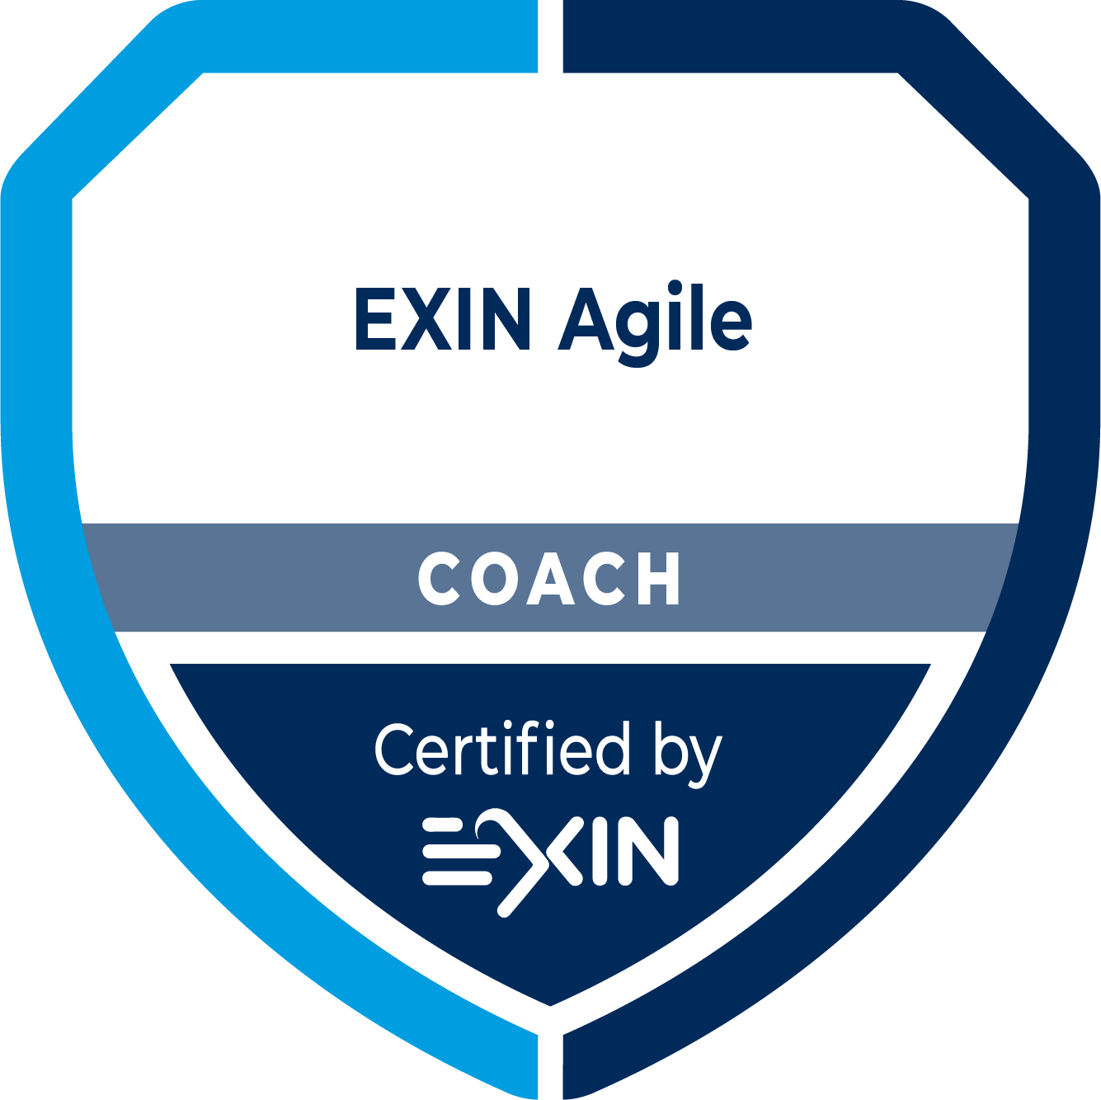
Candidate Application
Edition 202410
Application EXIN Agile Coach Assessment

Statement of Qualifications, Experience and Non-Disclosure
Please note that this form must be completed in English. All fields should be filled in.

All information, verbal or visual, exchanged between EXIN, Assessors and participating Candidates, is confidential and cannot be shared with others, without explicit approval of the data owner.

Please send this application, together with an up to date resumé (CV) and other requested documents, to candidatesupport@exin.com.

Assessment Day and Location
Application submission date:
Assessment session(s) day(s) and location (or remote):
(at least 3 months from now)

Your Details
Title Mrs/Mr
First name
Last name/Family name
Contact information (e-mail)
Country
Age

Relevant Training and Qualifications
- Please provide us with a minimum of 1 and a maximum of 8 relevant educational or training experiences.
- Provide the year attended in the first column.
- Please do not provide training older than 10 years.
- Reference information must include a name, company name, and a telephone number.
- If you can send proof of the training or course you have taken, please provide us with a copy. (Separate upload.) Indicate whether you send this proof with the application.

Year | Course provider | Course title | Short description | Reference info | Evidence
 |  |  |  |  | yes/no
 |  |  |  |  | yes/no
 |  |  |  |  | yes/no
 |  |  |  |  | yes/no
 |  |  |  |  | yes/no
 |  |  |  |  | yes/no
 |  |  |  |  | yes/no
 |  |  |  |  | yes/no

Coaching Experience
- Please provide us with a minimum of 3 and a maximum of 5 relevant coaching experiences, with a total of at least 6 months, in which you had the role of coach.
- Please provide experiences that illustrate the range of your expertise.
- Please do not describe coaching engagements older than 3 years.
- Description must include the context of your coaching activity and highlight the added (business) value of your coaching activity.

Year | Company/context | Short description

Short Essay
- Please provide an event summary of one of your coaching engagements listed under ‘Coaching Experience’.
- Please provide the contact details of a reference person who can confirm what you describe.
- Use the form below to describe the engagement.
- Be short and concise. Please use the indicated word count as guidance.
- In some cases, you may find it necessary to refer to other engagements to give a fully rounded view of your skills. This is acceptable but be concise.

1. Which engagement listed under Coaching Experience are you summarizing and why is this a good example?
(50-100 words)

2. Reference person for the engagement.
Name
Role at the time
Relationship with you in context of the engagement
Contact details
(phone or e-mail)

3. Is there anything specific about the background leading up to the engagement that we need to understand?
(150-200 words) If necessary, provide a brief description of the background leading to the event.

4. What were the outline terms for the contract for the engagement?
(50-100 words) Please do not breach client confidentiality. Please provide a concise paragraph describing the basic requirements of the engagement. Detail the length of the engagement and the number of persons involved in your engagement.

5. How would you describe the added value from the coaching engagement?
(500-1000 words) Please describe the coaching engagement in detail, highlighting the following:
- Your preparation for the event
- The experience and knowledge you used in this coaching engagement
- The methods and techniques you used and why you thought they were appropriate
- The tools, equipment and visual aids you used and why you thought these were appropriate
- The results of your coaching engagement for the people involved
- The results of your coaching engagement in terms of business value created
- Difficulties you encountered and how you handled them or what you learned from them

Signature
The Rules and Regulations for EXIN’s examinations apply to the EXIN Agile Coach exam. By signing this document, you attest to the truth of its content. EXIN may check the facts and contact the references you provide.

Signoff can be done by adding a picture of your signature.

Place: | Date: | Signature:


Contact EXIN
www.exin.com

