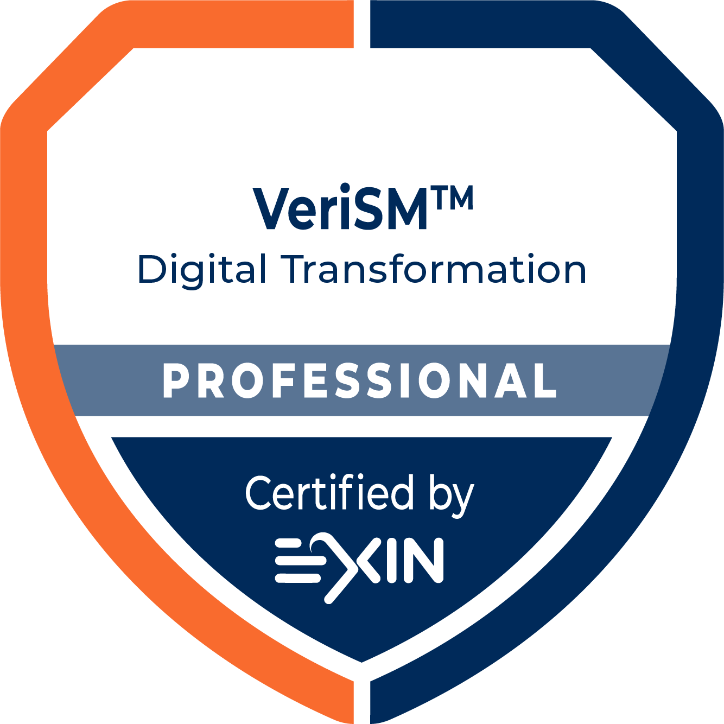

Practical Assignments
Edition 202510
Copyright © EXIN Holding B.V., 2025. All rights reserved.
EXIN® is a registered trademark.
VeriSM™ is a registered trademark of IFDC.
No part of this publication may be reproduced, stored, utilized or transmitted in any form or by any means, electronic, mechanical, or otherwise, without the prior written permission from EXIN.

Content
Introduction 4
Assignment 1: Management Mesh 6
Assignment 2: VeriSM™ Model 10
Evaluation 13
e-CF competences for VeriSM™ Professional 14

Introduction
Fulfillment of the practical assignments is part of the certification requirements for the VeriSM™ Professional certification.

Both the candidate and, if applicable, the trainer ensure that the candidate participates in the assignments in such a way that individual performance can be observed. This is particularly important in group assignments.

Adaptations
Accredited training organizations (ATOs) may set up practical assignments or simulations that fit the examples and use case studies presented in the training. The practical assignments do not need to follow the scenarios provided nor this certification’s case study. However, the scoring criteria may not be changed.

Adaptations can be assessed as part of the training materials audit on which the accreditation of the training organization is based. All assignments must be assessed based on the criteria provided by EXIN in the checklists in this document.

General guidelines
In general, the following guidelines should be followed in addition to the requirements per assignment:

- The candidate plans the activities within the assignment, unless otherwise stated.
- The candidate communicates with others where needed.
- The candidate provides their own solutions.
- The candidate contributes to the quality of the assignment, especially in group-work.
- Solutions provided are realistic and thus fit for the scenario or case study.
- Solutions provided match with business and IT objectives.

e-Competence Framework
The e-Competence Framework (e-CF) is an accepted and common framework developed in Europe (https://itprofessionalism.org/). EXIN supports the e-CF, because EXIN believes in professionals showing their competences and growing towards their full potential by helping them make their competences transparent (https://www.exin.com/astride-by-exin/). The competences tested in the VeriSM™ Professional certification are derived from the e-CF.

The practical assignments are used to demonstrate practical skills and experience which cannot be tested in a multiple choice exam. Making the practical assignments part of the certification scheme helps to test the entire competence.

Assessment
In order to complete the practical assignments, there needs to be a check that the activities in the assignment have been carried out and the requirements have been met. This check can be done by an accredited trainer from the ATO, or if the candidate has chosen to prepare for their exam through self-study, they are required to complete the practical assignments independently, including a check of their own work to confirm that they have completed the assignments according to the requirements. The person performing the check (whether a trainer or the candidate) needs to familiarize themselves with the assessment criteria.

Each assessment has assessment criteria that are based on the exam specifications and linked to the e-CF. The criteria are found in the checklists. The checklists need to be filled in for each individual candidate, stating whether or not the criteria have been observed.

In case completion of the practical assignments is checked by an accredited trainer, the ATO should save evidence that the practical assignments have been evaluated, this can be requested during an EXIN audit.

A candidate who has chosen to prepare for their exam through self-study is required to upload the outcomes, checklists and evaluation on https://mylogin.exin.nl. By uploading this document as evidence of training, the candidate declares that they have performed the activities of the practical assignments. EXIN is entitled to contact the candidate about the execution of the practical assignments.

Assignment 1: Management Mesh

Background
The case study of FCH.

You are hired as the principal consultant to the CEO.

Your assignment
The management team has decided to realize the following two strategic initiatives: ‘upgrade of the Electronic Medical Record (EMR) system’ and ‘upgrade the inpatient revenue systems with external support’. In your role as principal consultant you suggest some changes in order to anticipate future requirements very flexibly while considering practices that currently work well for the organization.

Create a Management Mesh to cover all topics (360° view) and to evaluate what is needed to achieve a sustainable, flexible environment within FCH.

Recommended time
1.5 hours

Reference materials
- VeriSM™: Unwrapped and applied, Appendix B: FireCloud Health case study
- VeriSM™: A service management approach for the digital age, Chapter 10
- VeriSM™: Unwrapped and applied, Chapter 12 and 14

Expected results
- The current Management Mesh and consider:
  - The four sides of the Mesh and the order to build the Mesh
  - How the Mesh should be filled
- The required Management Mesh based on the two chosen strategic initiatives and consider:
  - The four sides of the Mesh and the order to build the Mesh
  - The necessary elements to establish the two strategic initiatives
  - How the Mesh should be filled
- A description of the gaps

Assessment criteria for the exercise
The candidate can…
- understand the Management Mesh.
- apply the Management Mesh based on a case study with defined goals.
- perform a gap analysis.

Candidate’s outcomes:

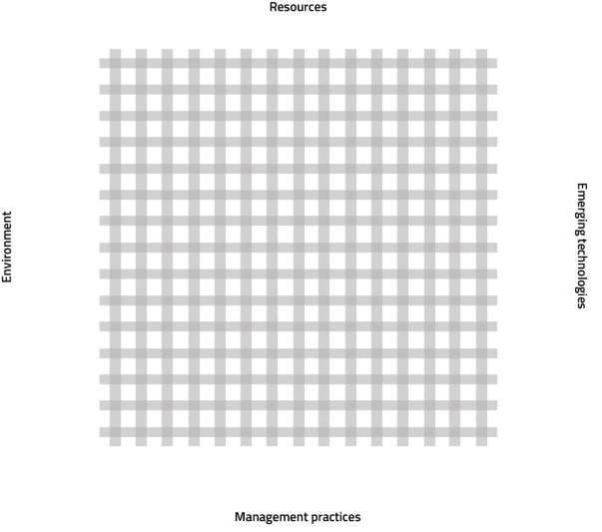
Current Management Mesh

Required Management Mesh

Candidate’s outcomes:

Click or tap here to enter text.

Assignment 1 Checklist
Note down the assessment of the candidate on each exam specification.

e-Competence | Exam specification | The candidate can... | Observed?  (Tick box if observed)
A.4., D.11. | 4.1.1 | apply the VeriSM™ model to address a new or changed product or service. | ☐
A.4. | 4.1.2 | capture the current state in a Management Mesh. | ☐
A.7., A.9. | 4.1.3 | identify resources, environment, management practices and technologies that support the new or changed product or service. | ☐
D.11. | 4.2.2 | analyze the gap between the current state and a desired state. | ☐

Assignment 2: VeriSM™ model

Background
The case study of FCH.

You are hired as the principal consultant to the CEO.

Your assignment
One of the strategic initiatives is continuing to grow and merging with one to three new hospitals.

FCH will merge with one new hospital. In your role as principal consultant, the management team asks you to create separate operational plans for HR in the medical division and both IT departments for this merger. These plans should include the activities throughout the four
VeriSM™ stages and the desired outcomes.

Recommended time
1.5 hours

Reference materials
- VeriSM™: Unwrapped and applied, Appendix B: FireCloud Health case study;
- VeriSM™: A service management approach for the digital age, Chapter 7, 11, 12, 13, 14;
- VeriSM™: Unwrapped and applied, Chapter 11, 13, 14, 15, 16, 17.

Expected results
- Operational plan for HR in the medical division including:
    - The activities throughout the four stages
    - The desired outcomes per stage
- Operational plan for IT as part of finance in the medical division including:
    - the activities throughout the four stages
    - the desired outcomes per stage
- Operational plan for IT in the insurance division including:
    - The activities throughout the four stages
    - The desired outcomes per stage

Assessment criteria for the exercise
The candidate can…
- process a strategic decision into operational plans running through the four stages.
- create an operational plan including desired outcomes.
- apply the VeriSM™ model to an organization.

Candidate’s outcomes:

Click or tap here to enter text.

Assignment 2 Checklist
Note down the assessment of the candidate on each exam specification.

e-Competence | Exam specification | The candidate can... | Observed?  (Tick box if observed)
D.11., E.4. | 4.2.1 | differentiate between traditional and iterative requirement gathering techniques (user stories; card, conversation, confirmation). | ☐
A.4. | 4.3.1 | analyze the Produce, Provide and Respond activities for conformance to organizational strategy and consumer need. | ☐

Evaluation
The final evaluation must be filled out below for each individual candidate. When a minimum of 4 out of 6 (65%) of the criteria have been observed, the candidate has successfully performed the practical assignments.

Please note that of the some exam specifications may be included in more than one assignment. If the requirement has been observed in at least one of the assignments, the exam specification may be assessed as ‘observed’.

e-Competence | Exam specification | The candidate can... | Observed?  (Tick box if observed)
A.4., D.11. | 4.1.1 | apply the VeriSM™ model to address a new or changed product or service. | ☐
A.4. | 4.1.2 | capture the current state in a Management Mesh. | ☐
A.7., A.9. | 4.1.3 | identify resources, environment, management practices and technologies that support the new or changed product or service. | ☐
D.11., E.4. | 4.2.1 | differentiate between traditional and iterative requirement gathering techniques (user stories; card, conversation, confirmation). | ☐
D.11. | 4.2.2 | analyze the gap between the current state and a desired state. | ☐
A.4. | 4.3.1 | analyze the Produce, Provide and Respond activities for conformance to organizational strategy and consumer need. | ☐

Total number of specifications observed:
Candidate passed/failed:

e-CF competences for VeriSM™ Professional
You can find the e-Competence Framework competences tested in the VeriSM™ Professional certification below. Also indicated is the level of the competence and whether the competence is covered entirely, partially or superficially. For more information about the e-CF, please visit https://itprofessionalism.org/ or contact EXIN.
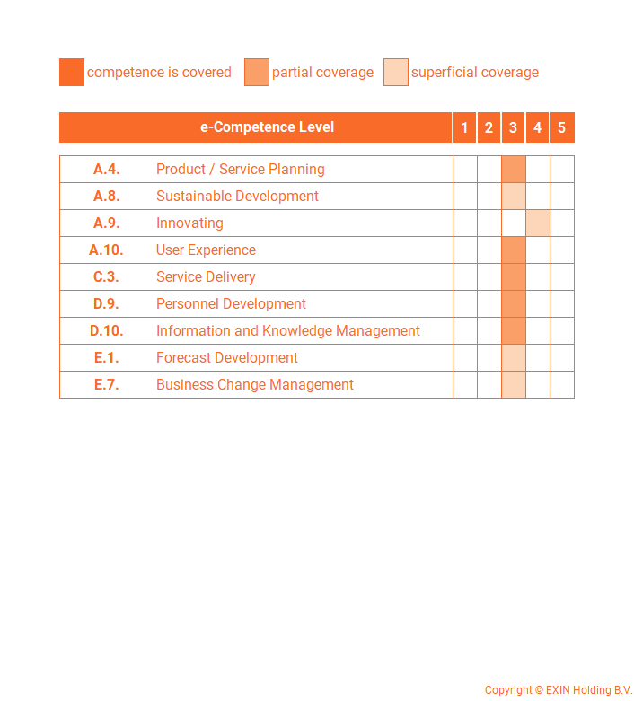


Contact EXIN
www.exin.com

